**Ch 14 - More About Quantification**

**Many English sentences take the form** Q A B

where Q is a **determiner expression** like **every, some, the, more than half the, at least three, no, many, Max’s, etc**

**Example**

* Every cube is small.
* Max’s cube is small.

Such sentences express quantitative relationships between sets of objects, e.g. the set of cubes and the set of small things.

**Numerical Quantification**

* **numerical claim:** one that explicitly uses the numbers 1, 2, 3, … to say something about the relationship between the A’s and the B’s.
* **examples**
  + At least two books arrived this week.
  + At most two books are missing.
  + Exactly two books are on the table.
* FOL, in general does not allow us to talk directly about numbers, only about elements in our domain of discourse
  + still, we can express the notions in the three examples above in FOL
* numerical quantification, when written out in full in FOL, is hard to read (lots of inequalities)
* an abbreviation can be used (the abbreviation is not part of FOL)

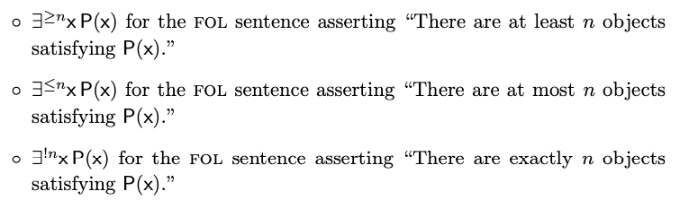

**example:** There is exactly one object satisfying some condition P(x).



Abbreviated as



But so common that is further shortened to



“there is a unique x such that P(x)”

* don’t forget that these expressions don’t involve new FOL quantifiers; they are simply abbreviations for longer wffs involving the old quantifiers
* when trying to prove , prove two things: that there are at least nobjects satisfying P(x), and that there are at most n such objects
* since numerical quantifiers are really shorthand for more complicated expressions in FOL, there is no real need to introduce rules that specifically apply to them.
* of course, the same could have been said for ->, but we saw it was much more convenient to have rules of proof for -> than to reduce things to | and ~ and use their rules of proof
* but the situation is different with numerical quantifiers
* in practive, people rarely give formal proofs of numerical claims expressed in FOL, since they quickly become too complex, with or without special rules for these quantifers
* **with numerical claims, informal proofs are the order of the day**

**the, both, neither**

* English determiners *the, both, neither* are extremely common
* their logical properties are subtle and still a matter of some dispute
* **example**
  + *The elephant in my closet is not wrinkling my clothes.*
* **How to determine the truth value of this sentence?**
  + if the elephant is not in closet, or if there are three?
* **Bertrand Russell’s take**
  + *The cube is small* should be analyzed as asserting that there is exactly one cube, and that it is small.
  + False if there is no cube, or if more than one cube, or if exactly one but not small
  + The sentence, under this interpretation, is expressed  
    
  + more generally, noun phrases of the form *the A is B*, under Russell analysis is translated as  
    
  + noun phrases of the form ***the A*** are called **definite descriptions** and such analysis is called **Russellian analysis of definite descriptions**
* the Russellian analysis is as close as we can come in FOL, it is important, and it captures at least some uses of these determiners
* there is no universally accepted theory of how these determiners work in English

**Adding Other Determiners to FOL**

* there are many determiners that aren’t expressible in FOL
  + e.g. most
* the meaning of **most** is a bit indeterminate
* it clearly means **more than half** but does more than half imply most?
* if we take it to mean more than half, can we express it in FOL? Turns out no.
* for any determiner Q
  + **general form:** any use of the form Q A B
  + **special form:** any use of the form Q thing(s) B

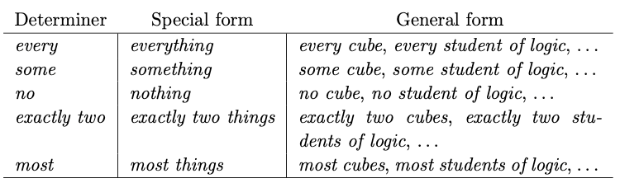

* if a determiner has the property that the general form can be reduced to the special form by a suitable use of truth-functional connectives then the determiner is called **reducible**
* some determiners, including **most, many, few,** and **the** are not reducible
  + for these, we cannot add Q to FOL by simply adding the special form as a new quantifier symbol
* since **every** and **some** are reducible, FOL uses their special forms
* if we want to add a new quantifier like **Most** to FOL we must add the general form
* the formation rule
  + takes two wffs and a variable to create a new wff
    - if A and B are wffs and v is a variable, then Most v (A,B) is a wff, and any occurrence of v in Most v (A,B) is said to be bound.
  + Most x (A,B) is read “most x satisfying A satisfy B”
    - Most expresses a binary relation between the set A of things satisfying A and the set B of things satisfying B
* given this general pattern, we can add any meaningful determiner Q of English to FOL
  + if A and B are wffs and v is a variable, then Q v (A,B) is a wff, and any occurrence of v in Q v (A,B) is said to be bound.
* Q x (A,B) is “Q x satisfying A satisfy B”, ie “Q A’s are B’s”